Ayesha Zubair
52916
CFG Lab 6

Task 1:
S → A B
A → a A | ε
B → b B | c

Output:
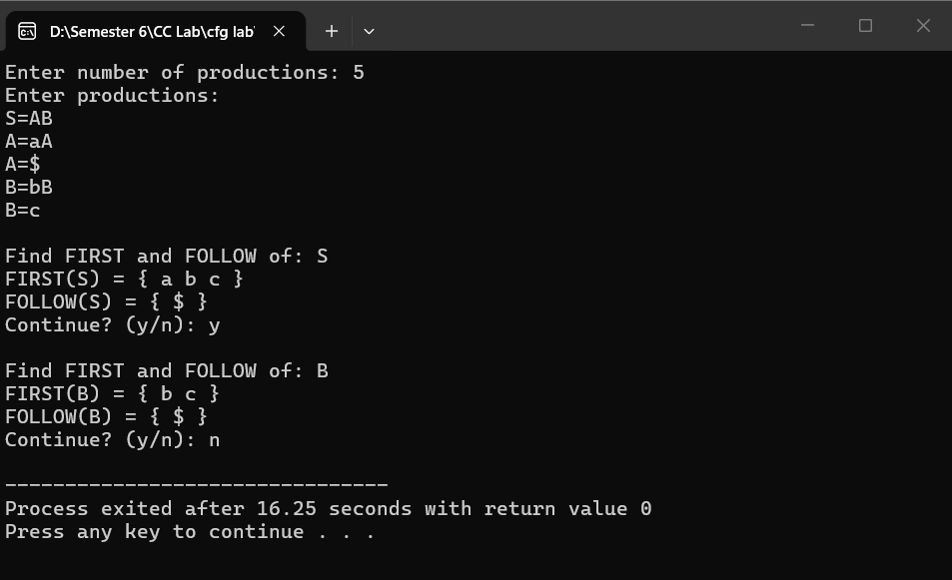
Task 2:
E → T R
R → + T R | ε
T → F Y
Y → * F Y | ε
F → ( E ) | id
Output:
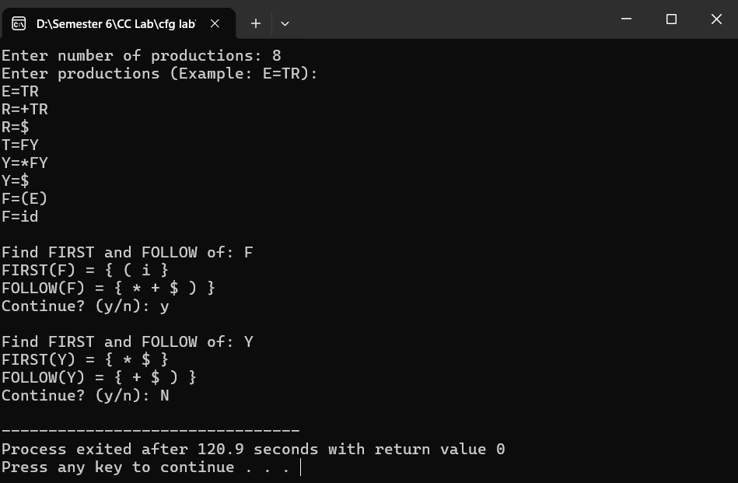
Task 3:
S → A B C
A → a | ε
B → b | ε
C → c

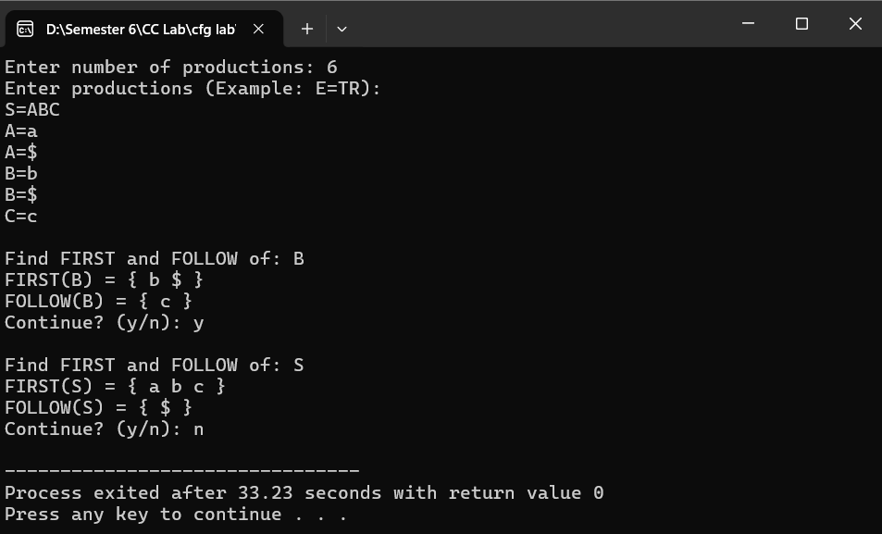

Task 4:
S → a S | b A
A → c A | d
Output:
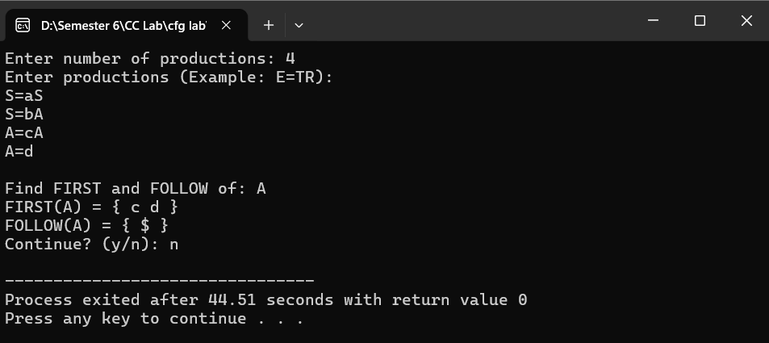

Task 5:
S → ( S ) S | ε
Output:
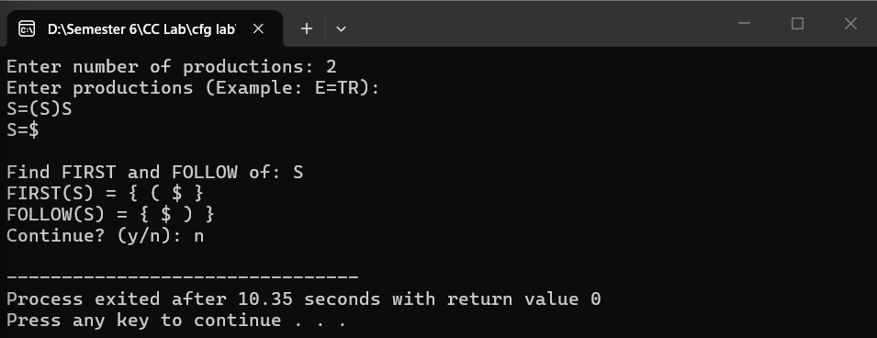

Task 6:
S → A B
A → a | ε
B → b C
C → c | ε
Output:
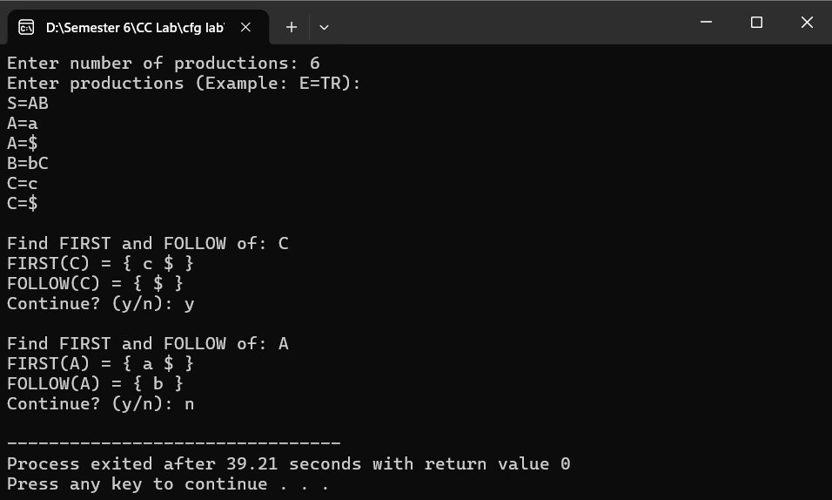

Task 7:
E → T E'
E' → + T E' | ε
T → F T'
T' → * F T' | ε
F → id | ( E )
Output:
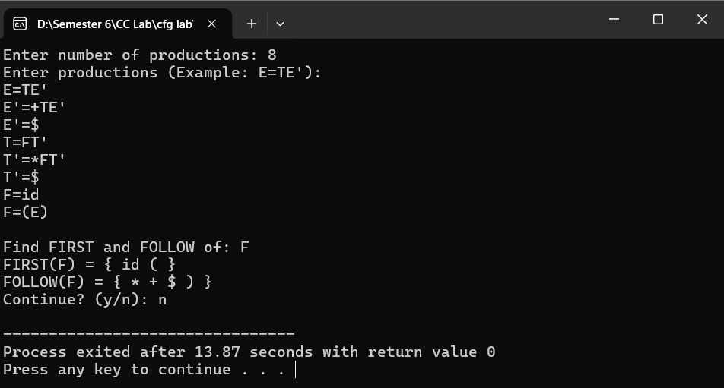

Task 8:
S → A B
A → B a | ε
B → b | ε

Output:
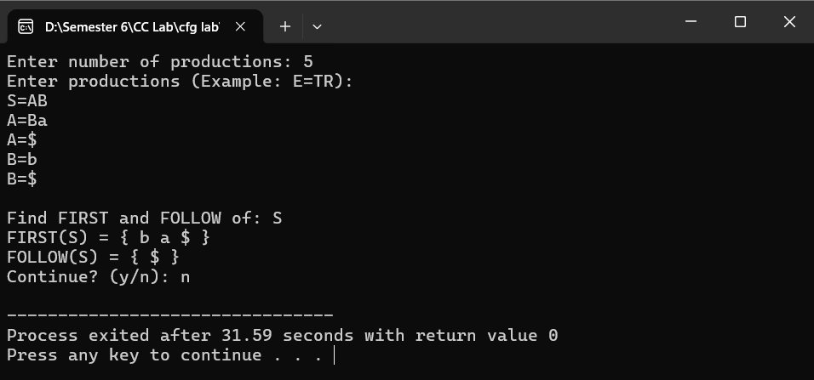

Task 9:
S → A B C
A → a A | ε
B → b B | ε
C → c C | d

Output:
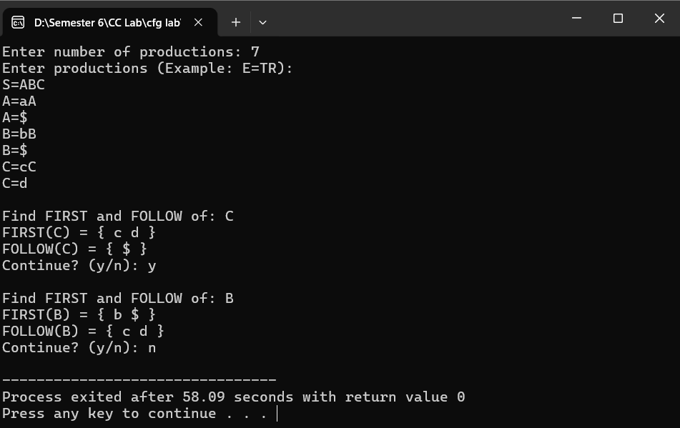

Task 10:
S → A C B
A → a A | ε
B → b B | ε
C → c | d

Output:
